Adding user for application access

1)Browse the application URL

<https://poc-emea-lidl.insights2execution.com/platform>

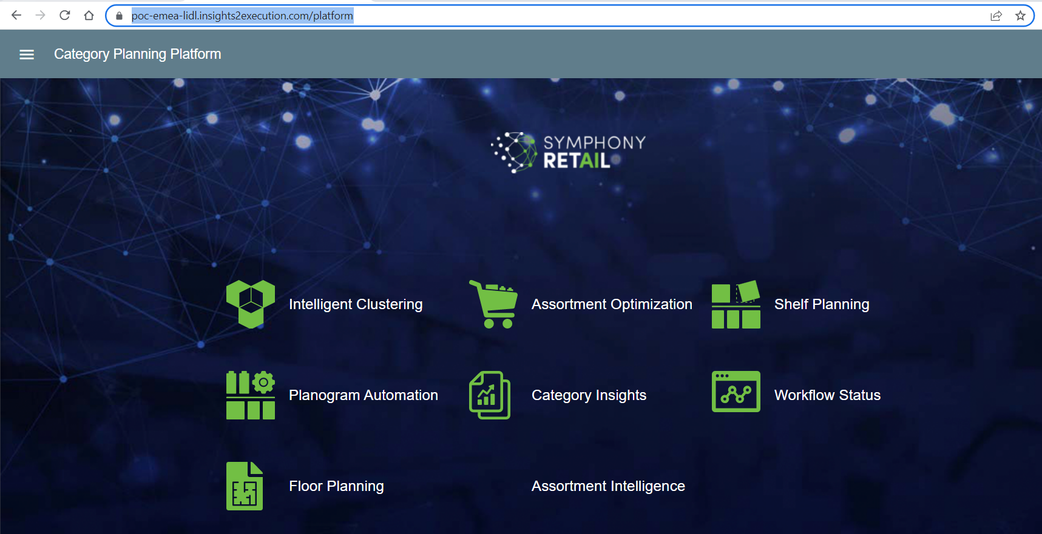

2)Go to menu and permission>>

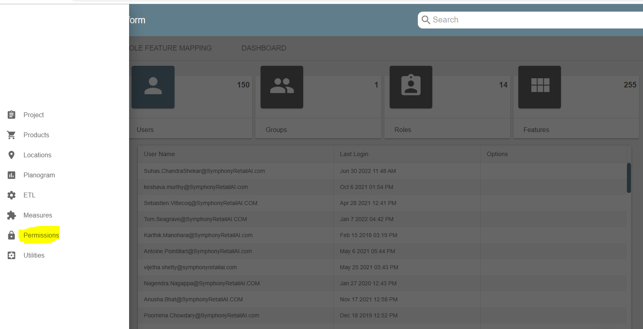

3)Create user + Based on the requirement we have to select, group, role, language and submit

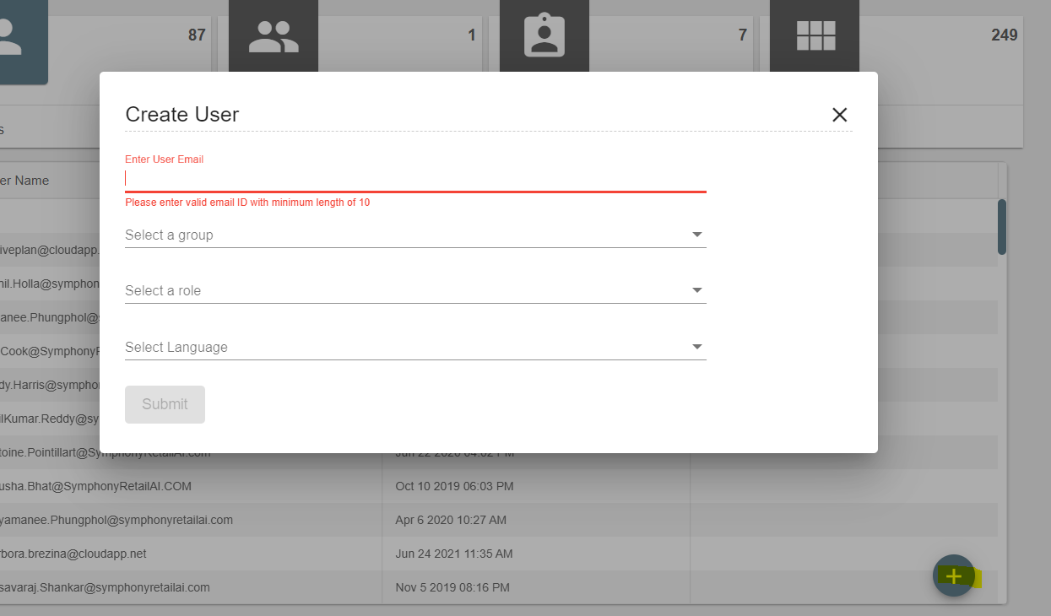

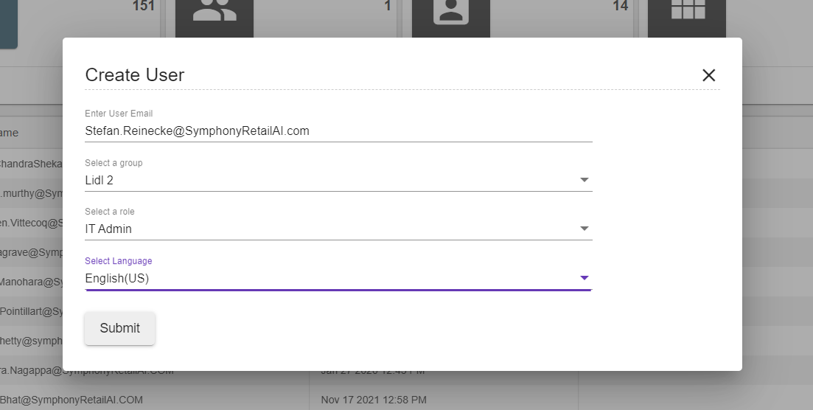

``````````__________END_________________`````````